Pass for level 7: DBfUBfqQG69KvJvJ1iAbMoIpwSNQ9bWe

Step 1: entering to natas 7

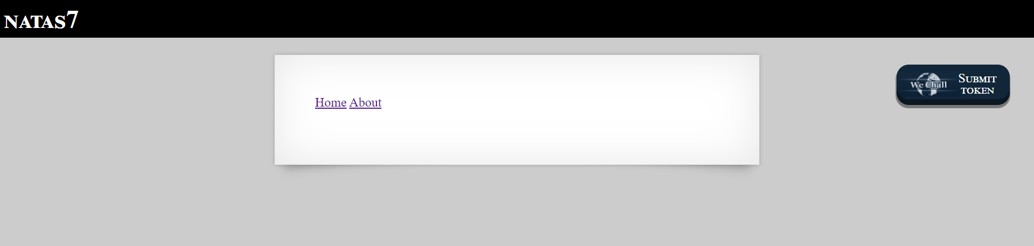

Step 2:Playing with the buttons

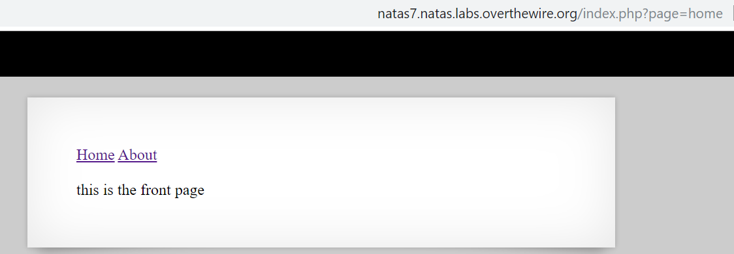

Step 3: understanding the syntax of the url

We need to set home to some path.

Step 4:opening the source code and see clues

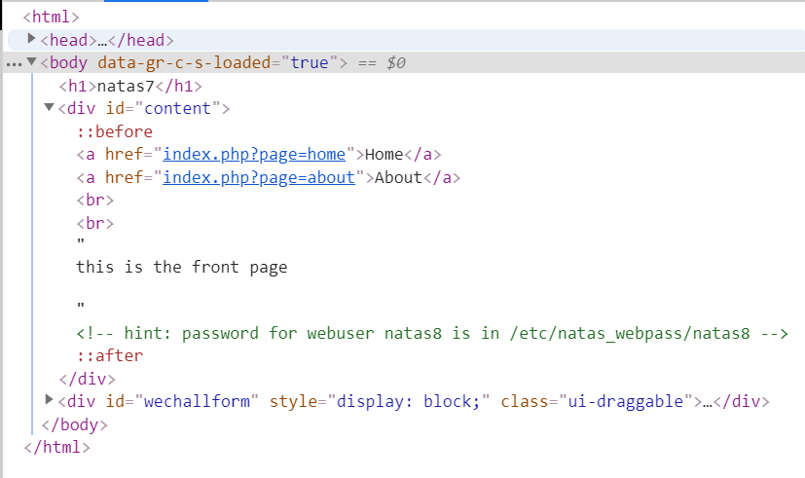

Step 5:setting the new path

Entering to <http://natas7.natas.labs.overthewire.org/index.php?page=/etc/natas_webpass/natas8>

Results:

